Task on IAM
- Create one IAM user and assign EC2 and S3 full access roles.
Click on the create user and give your name and add your custom password
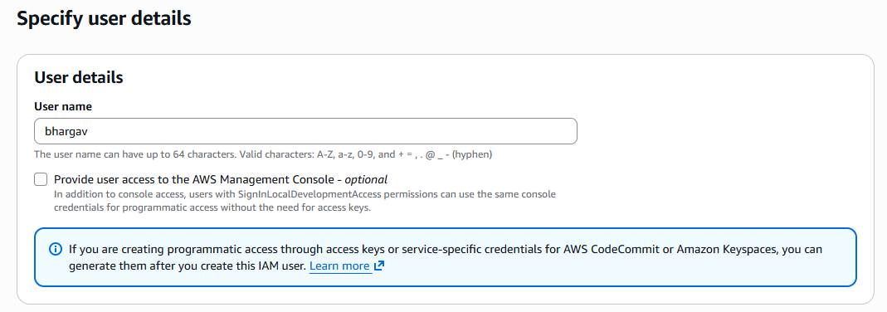

Attach policies
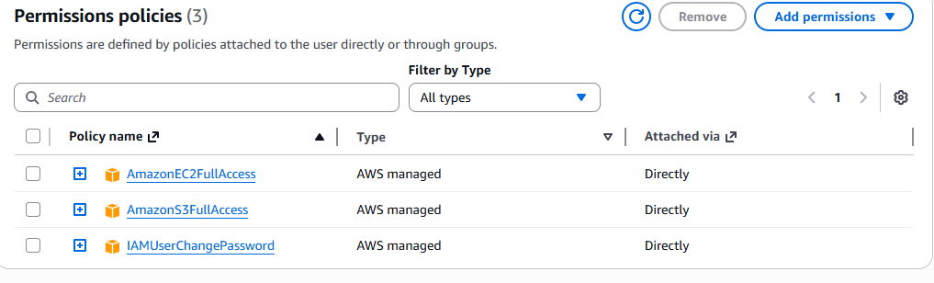

You can copy the URL , hit the browser and select IAM user and give your user name and password which we are created
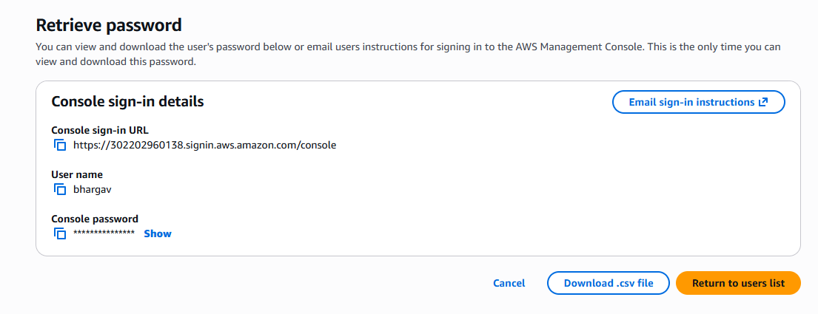
2. Create one group in IAM and assign read access for EC2.

Click on the create user group
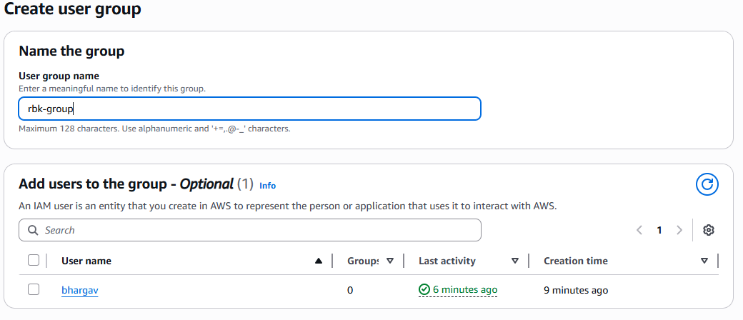

Attach policies
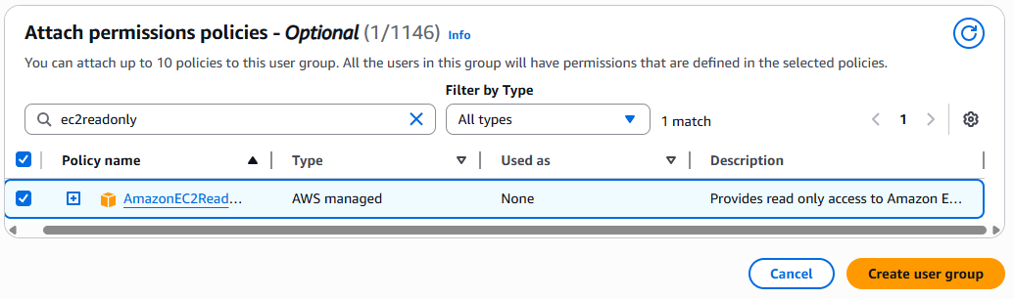
3. Create a new user named "Devops" and add to the group created in task 2.
Create user and add user to group which we are created in task2
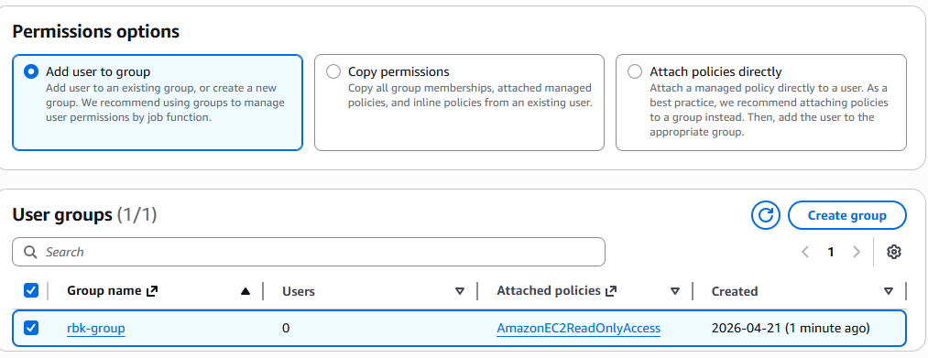

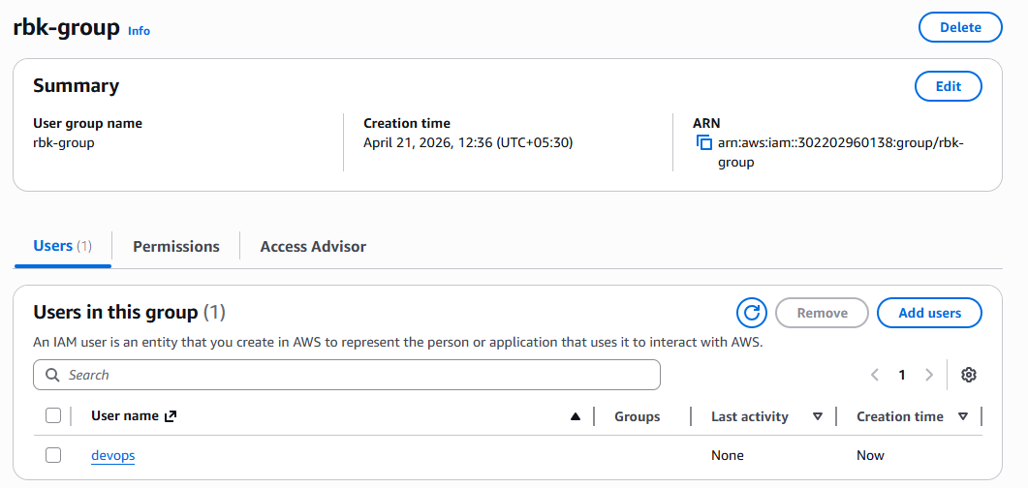
4. Write a bash script to create an IAM user with VPC full access.

Write a bash script to create an IAM user with VPC full access
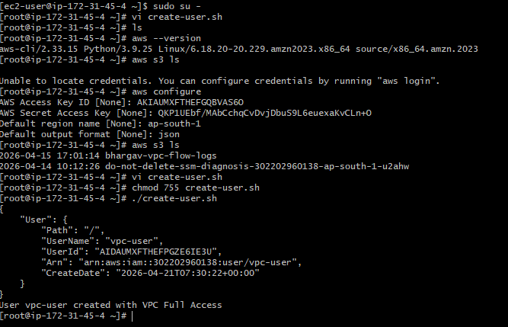

We can check in the console, weather the user created or not
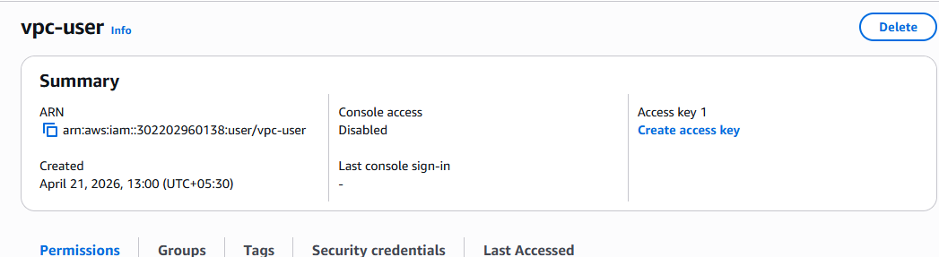

Check the policies as well
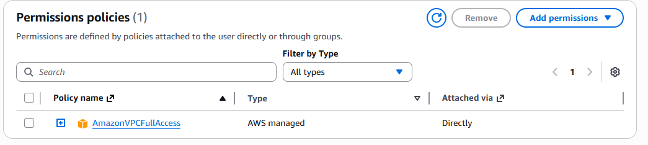
5. Create an IAM policy to allow EC2 access for a specific user in specific regions only.

Create police
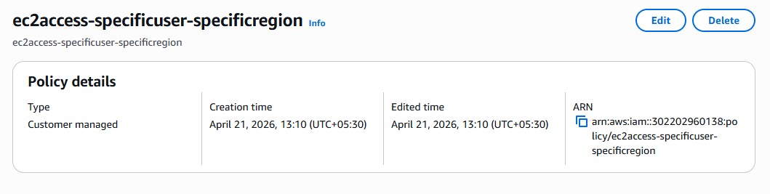

We can add the script in Json format for EC2 access for a specific user in specific regions only.
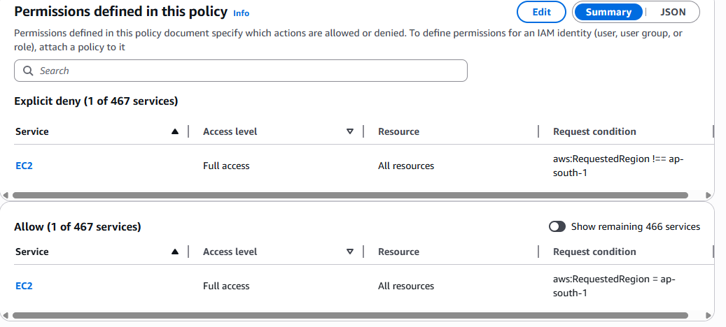
6. We have two accounts: Account A and Account B. Account A user should access an S3 bucket in Account B.
(Collaborate with a team member and execute this. This is mostly asked in every interview.)

IAM → Users → user1 → Add Permissions
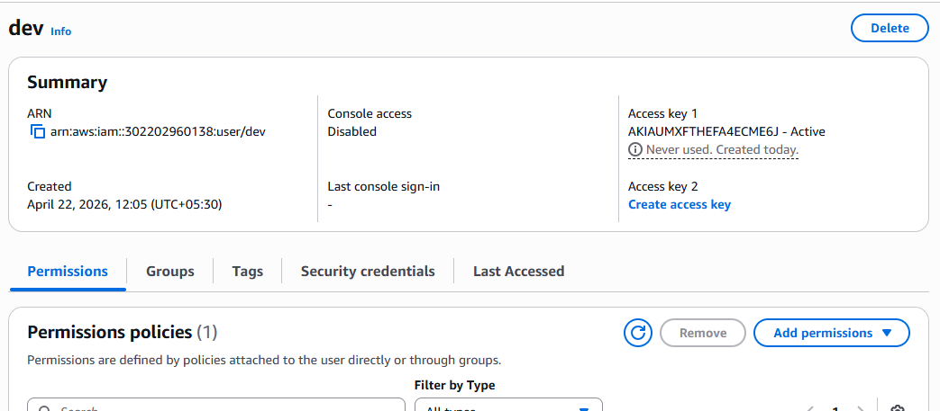

Create or attach policy:
User is allowed to access that bucket
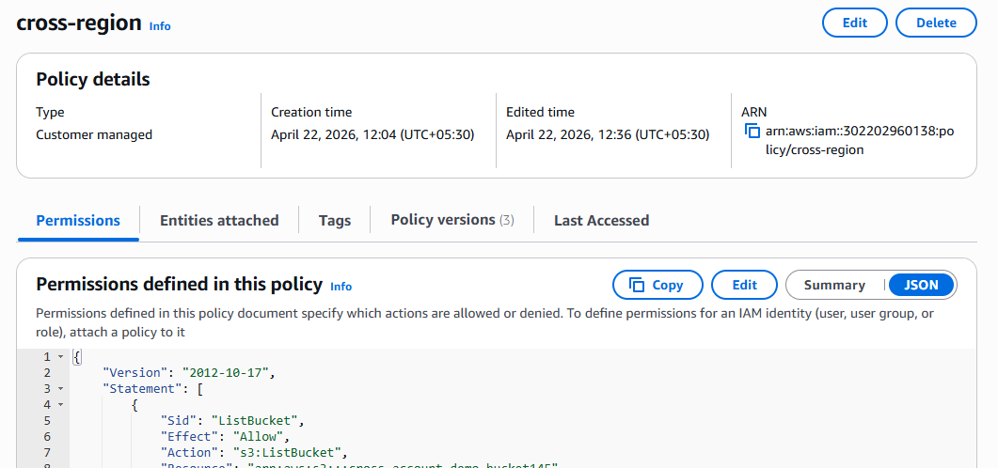

From my Account user (CLI):
Check the friend account bucket from my account
